College Network Design Project Report

A report submitted in partial fulfilment of the requirements

for the award of degree of

Bachelor of Technology

In

Computer Science and Engineering

Submitted by: Submited to:

Shivanshu Sharma Mr. Vinod sir



Delhi Global Institute of Technology

Bahadurgarh, Jhajjar, Haryana 124201

Affiliated to

Maharshi Dayanand University

CERTIFICATE

This is to certify that the Project College Network Design submitted by Shivanshu Sharma, to Maharishi Dayanand University(MDU), Rohtak-124001, Haryana in partial fulfilment of the requirement for the award of semester 6th of the degree of B.Tech in Computer Science Engineering. This project full-fills the requirement as per the regulation of the institute of university in my opinion meets the necessary standards for submission. The contents of this report have not been submitted and will not be submitted either in part or in full, for the award of any other degree or diploma in this time institute or any other institute or university to the best of my knowledge and belief.

Mentor Signature-

ACKNOWLEDGEMENT

It has been great honour and privilege to undergo this project. I have taken efforts in this project. However, it would not have been possible without the kind support and help of many individuals. I would like to extend my sincere thanks to all. I am highly indebted to professors for their guidance and constant supervision as well as for providing necessary information regarding the project and for their support in completing the project. Their constant guidance made me understand this project and its manifestations in great depths helped us to complete the assigned tasks on time. I am also thankful and grateful to my parents who helped me throughout this project period.

Shivanshu Sharma

B.tech (CSE)

DECLARATION

I here by declare that the project report entitled “College Network Design” submitted by me. Shivanshu Sharma partially fulfilment the requirements for this project work under the guidance of professors. I also declare that, the report is only prepared for my academic requirement not for any other purpose.

|  |  |  |
| --- | --- | --- |
| S.no | TOPIC | Page No. |
| 1 | Objectives |  |
| 2 | Problem Statements |  |
| 3 | Introduction |  |
| 4 | Proposed technology |  |
| 5 | Theory |  |
| 6 | Routing protocols |  |
| 7 | Project Details |  |
| 8 | Requirements |  |
| 9 | Campus Layout |  |
| 10 | implementation |  |
| 11 | Conclusion |  |
| 12 | Future scope |  |
| 13 | References |  |

Objectives

- Design an Efficient College network Design.

- Covering different domains in a college and establishing a sample

network of the entire Branch.

- Connecting student to internet, data sharing among different people, accessing different devices for different functionalities.

- Providing students, teachers, and different Campus members for

assessable applications.

- Imitate the behavioural characteristics of humans and create their

individual relationships based on the rules or requirements placed by

their owner with the advantage of enhancing the network scalability in information/service discovery.

PROBLEM STATEMENT

The Problems identified are as listed below:

1. In complex networks there can be looping which will be unnecessary collisions which can lead to dysfunctional system cause data losses.

2. In wireless communication there can hidden node and hidden terminal problem that can occur when there is discrepancy to the object’splacement and its listening and transmitting ranges. This again can cause dysfunction by listening to other nodes when there is no need nor authorization.

3. System security as there is remote access for devices in the room by a subscriber and control node which when accessed by the wrong entity can control system and endanger security.

The problems were taken care of by:

1. Using Spanning Tree Protocol which nullifies the formation of loops problem.

2. The devices that could be hidden terminals and hidden nodes are kept out of each other’s listening and transmitting range and preferably in separate rooms.

3. Each room has a subscriber and control node in the form one Authorized device for the access of all the IOT devices remotely. 4. The IP address of this device is configured in the gateway and it is also protected by an admin login. Hence, it’s a two fold protection where the misuser will have to get hold of the authorized control device first and then crack through the admin login to misuse the system.

INTRODUCTION

The Internet is expanding with a tremendous speed so as its Security. Security is a very important field that consist of the provisions made in computer networks infrastructures, policies adopted by the network administrator to protect networks, the network-accessible resources from unauthorized access and effectiveness of measures combined together.

Personal, government and business applications continue to multiply on the Internet and workbased application and services can pose security risks to individuals and to information resources of companies and government. Information is an asset that must be protected.

Network security is more challenging than ever, as today’s college networks becomes increasingly complex.

As the campus network started late, and the school funds are not very adequate, cannot be in one step. On the other hand, the level of application of the school is more uneven, some systems even if the installation is not used, therefore, in the construction of the campus network process, the system should always implement the application-oriented, pragmatic approach, the principle of economy.

The school network needs to complete, including the book information, school administrative office and other integrated business information management system for the majority of faculty and students to provide a network environment for teaching and research work of the advanced platform.

The campus network covers the entire campus, and the network design follows the following five basic principles:

Reliability and high-performance networks must be reliable, including network-level reliability such as routing, switching aggregation, link redundancy, and load balancing. The network must be of sufficient performance to meet the needs of the business.

Scalability and scalability of the system to be scalable and scalable, with the business growth and application level, the network of data and information flow will grow exponentially, the need for good network scalability, and can continue to upgrade with the development of technology. Equipment should be used in line with international standards of systems and products to ensure that the system has a long vitality and scalability to meet future requirements of the system upgrade.

Proposed Technology

CiscoPacket Tracer

Cisco packet tracer is a cross-platform visual simulation tool designed by Cisco Systems that allows users to create network topologies and imitate modern computer networks. The software allows users to simulate the configuration of Cisco routers and switches using a simulated command line interface. Packet Tracer makes use of a drag and drop user interface, allowing users to add and remove simulated network devices as they see fit. The software is mainly focused towards Cisco Networking Academy students as an educational tool for helping them learn fundamental CCNA concepts. Previously students enrolled in a CCNA Academy program could freely download and use the tool free of charge for educational use.

Packet Tracer allows students to design complex and large networks, which is often not feasible with physical hardware, due to costs.

Packet Tracer is commonly used by NetAcad students, since it is available to them for free.

**OPERATING SYSTEM**

An operating system (OS) is the program that, after being initially loaded into the computer by a boot program, manages all of the other application programs in a computer. The application programs make use of the operating system by making requests for services through a defined application program interface (API).

**Theory**

**Types of Topology**

1. **Physical Topology:**A physical topology describes the way in which the computers or nodes are connected with each other in a computer network. It is the arrangement of various elements (link, nodes, etc.), including the device location and code installation of a computer network. In other words, we can say that it is the physical layout of nodes, workstations, and cables in the network.
2. **Logical Topology:**A logical topology describes the way, data flow from one computer to another. It is bound to a network protocol and defines how data is moved throughout the network and which path it takes. In other words, it is the way in which the devices communicate internally.

**Six types of physical topology**

1. 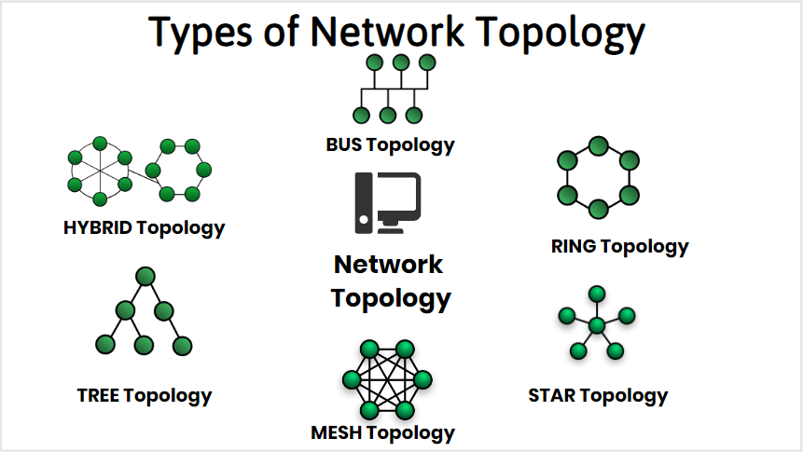Bus Topology
2. Ring Topology
3. Star Topology
4. Mesh Topology
5. Tree Topology
6. Hybrid Topology

**Routers**

A router receives and sends data on computer networks. Routers are sometimes confused with network hubs, modems, or network switches. However, routers can combine the functions of these components, and connect with these devices, to improve Internet access or help create business networks.

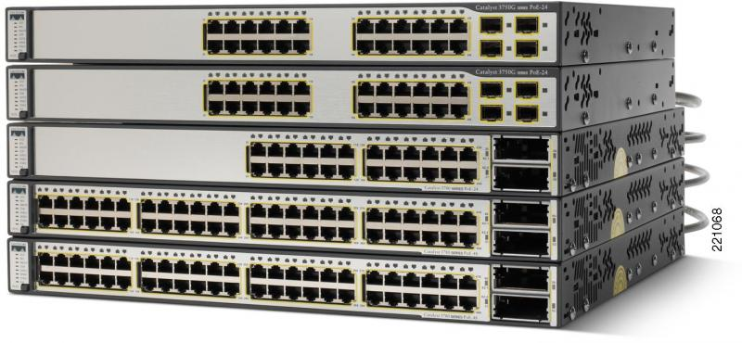

**Hubs & Switches**

A network hub is a central connection point for devices in a local area network, or LAN. But there's a limit to the amount of bandwidth users can share on a hub-based network. The more devices are added to the network hub, the longer it takes data to reach its destination. A switch avoids these and other limitations of network hub.

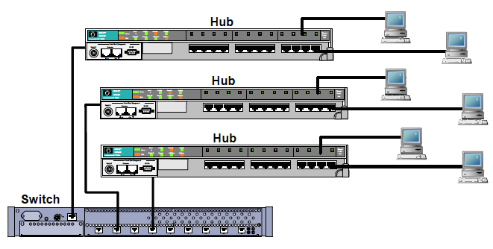

**Servers**

A server is a piece of computer hardware or software (computer program) that provides functionality for other programs or devices, called "clients". This architecture is called the client–server model. Servers can provide various functionalities, often called "services", such as sharing data or resources among multiple clients, or performing computation for a client. A single server can serve multiple clients, and a single client can use multiple servers. A client process may run on the same device or may connect over a network to a server on a different device. Typical servers are database servers, file servers, mail servers, print servers, web servers, game servers, and application servers.

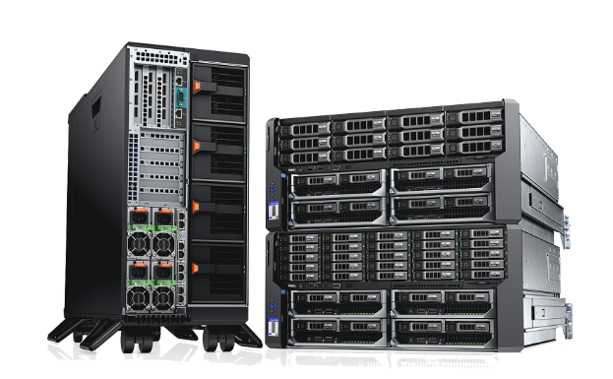

**OSI Model**

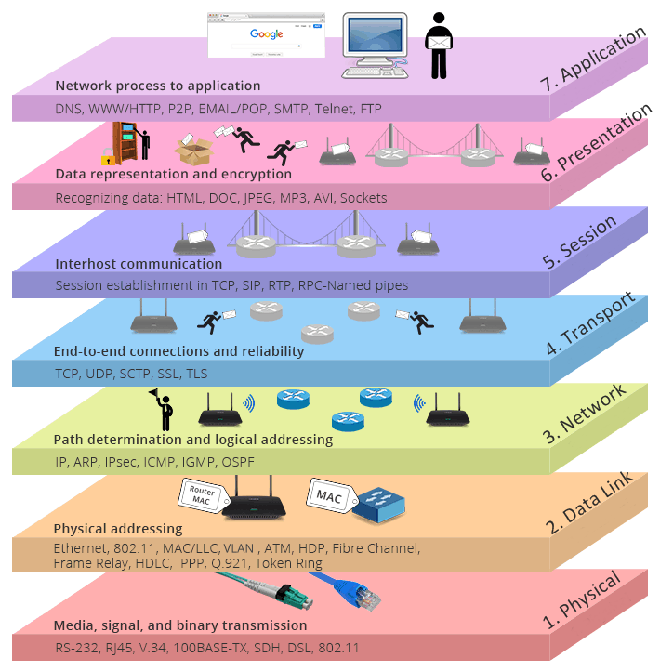The Open Systems Interconnect (OSI) model is a conceptual framework that describes networking or telecommunications systems as seven layers, each with its own function

**Routing protocols**

A routing protocol specifies how routers communicate with each other to distribute information that enables them to select routes between nodes on a computer network. Routers perform the traffic directing functions on the Internet; data packets are forwarded through the networks of the internet from router to router until they reach their destination computer. Routing algorithms determine the specific choice of route. Each router has a prior knowledge only of networks attached to it directly. A routing protocol shares this information first among immediate neighbors, and then throughout the network. This way, routers gain knowledge of the topology of the network. The ability of routing protocols to dynamically adjust to changing conditions such as disabled connections and components and route data around obstructions is what gives the Internet its fault tolerance and high availability.

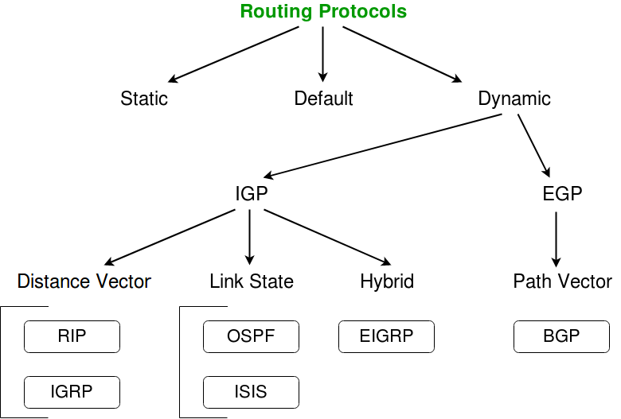

**NAT AND PAT**

Port Address Translation (PAT) is an extension of Network Address Translation (NAT) that permits multiple devices on a LAN to be mapped to a single public IP address to conserve IP addresses.

PAT is similar to port forwarding except that an incoming packet with destination port (external port) is translated to a packet different destination port (an internal port). The Internet Service Provider (ISP) assigns a single IP address to the edge device. When a computer logs on to the Internet, this device assigns the client a port number that is appended to the internal IP address, giving the computer a unique IP address.

This module describes how to configure Network Address Translation (NAT) for IP address conservation and how to configure inside and outside source addresses. This module also provides information about the benefits of configuring NAT for IP address conservation.

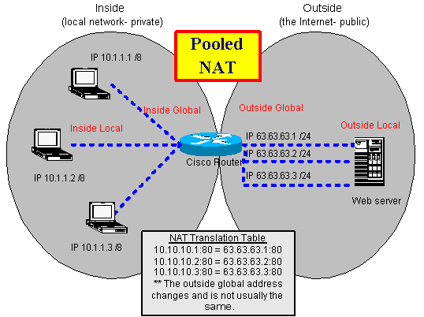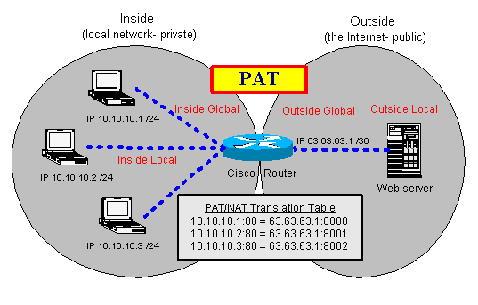

**OSPF & BGP**

While BGP excels with dynamic routing for large networks, OSPF offers more efficient path choice and convergence speed. Border Gateway Protocol, or BGP, and Open Shortest Path First, or OSPF, are two of the most popular, standards-based dynamic routing protocols used around the world.

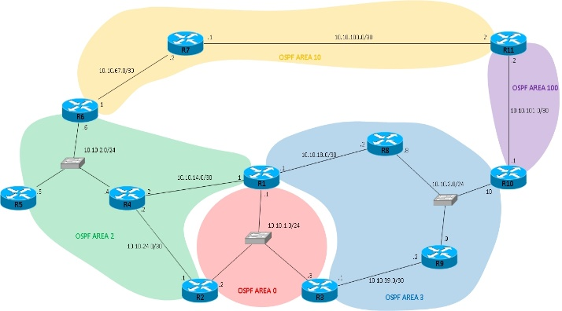

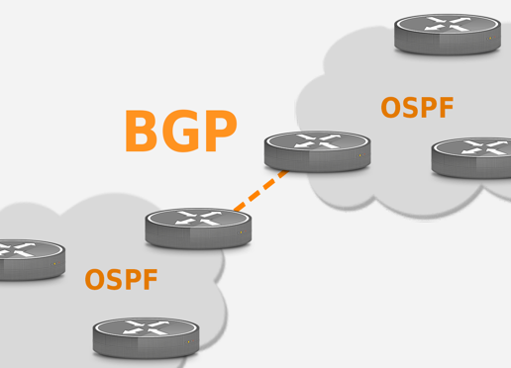

**PROJECT WORK**

**OBJECTIVE**

To build a network for your college campus.

**CONTEXT**

College campus network is generally the portion of the enterprise network infrastructure that provides access to network communication services and resources to end users and devices that are spread over a single geographic location.

It specifies whether the design is for a single network segment, a group of LANs, a building or campus network, a group of WAN or remote-access networks, or perhaps the entire campus network.

**Steps and Tasks**

1. Make a layout of the area where to establish a network.
2. Select the devices according to the need in the premises.
3. Specific area should have its own main router.
4. Each main router should be connected with each other by routing protocols.
5. Then provide IP address to the network and subnet according to their users in the premises.

**ROUTER CONFIGURATION COMMANDS**

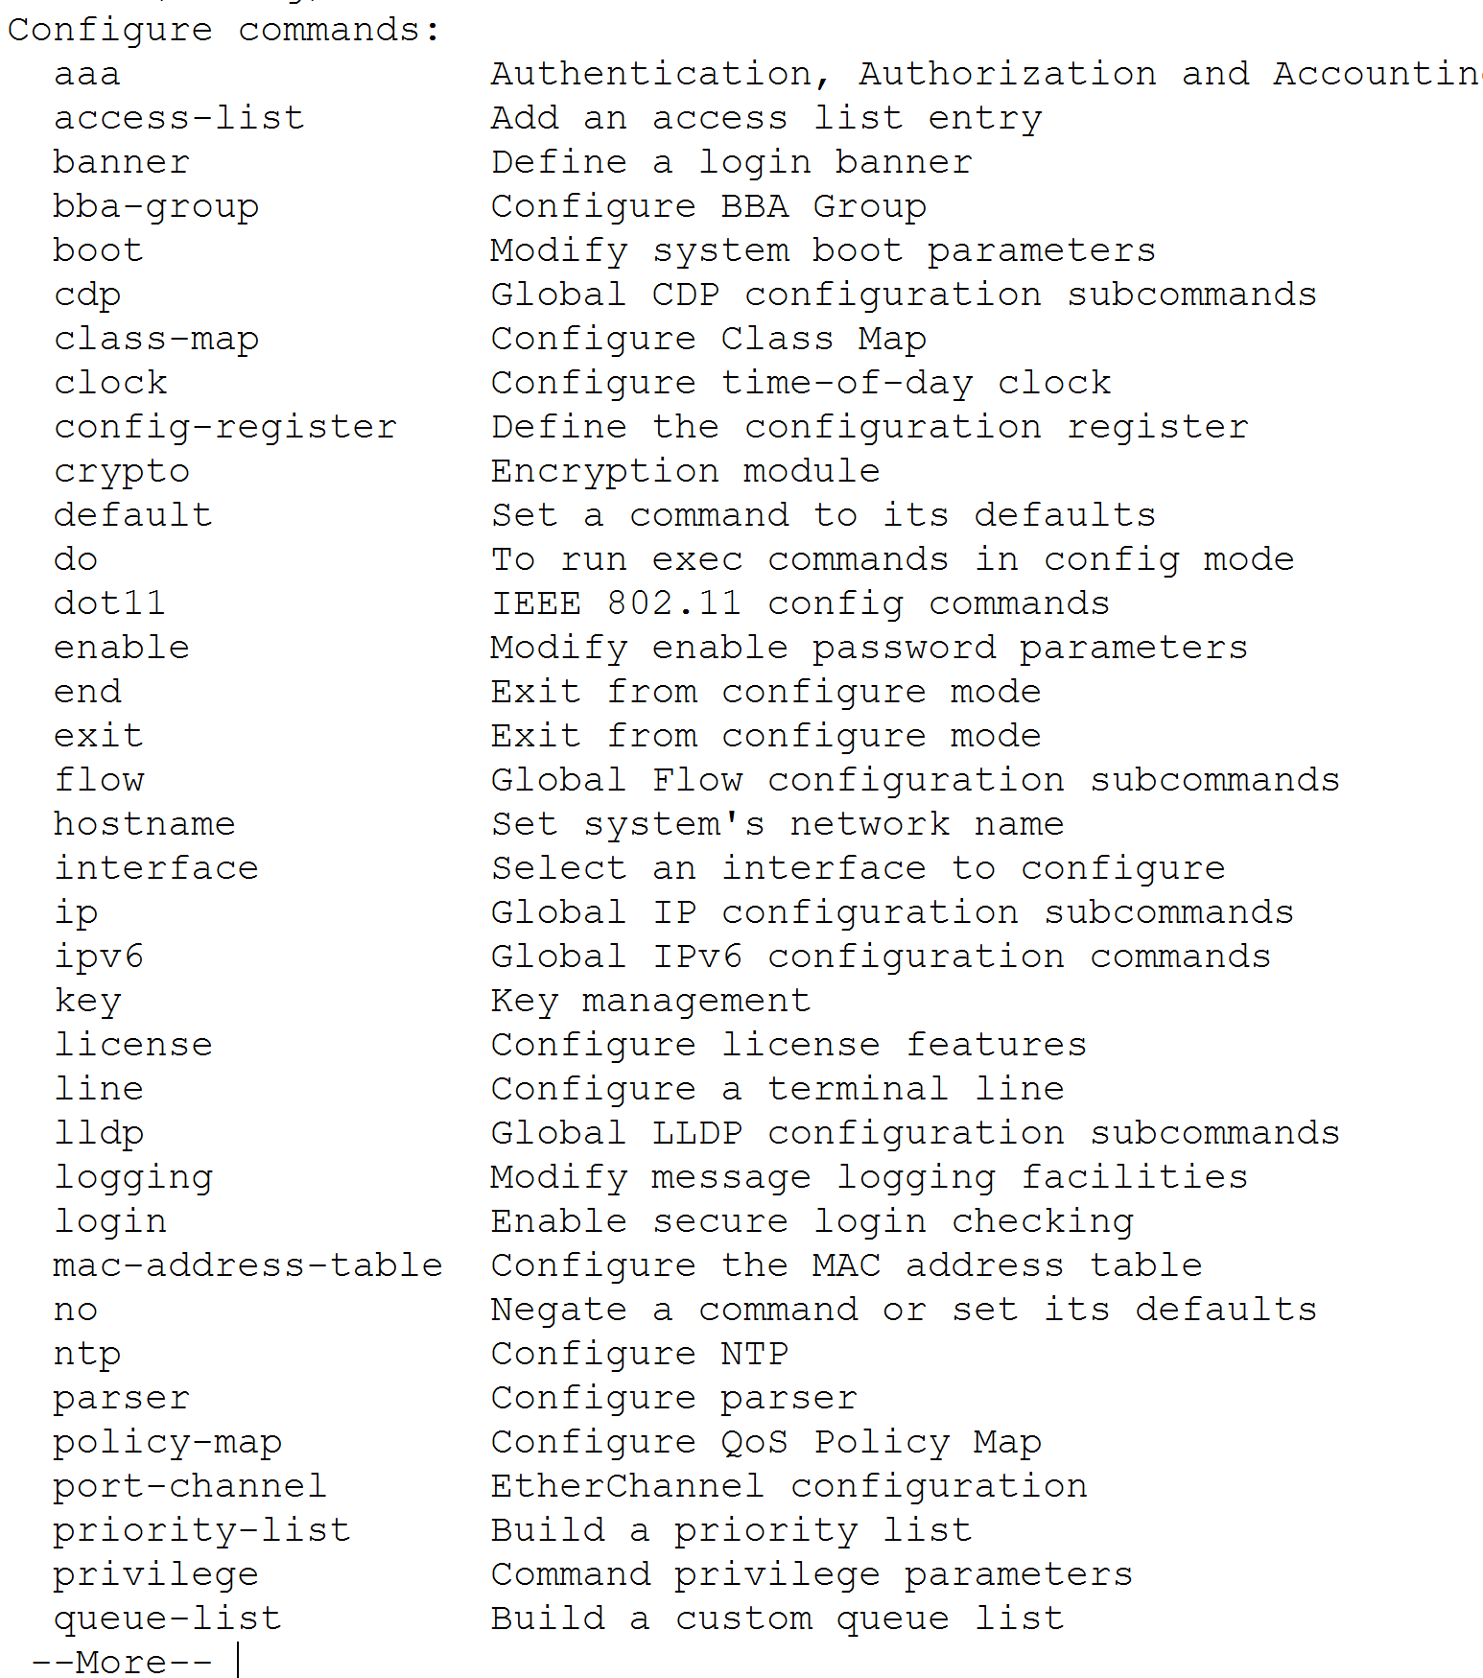

**SWITCH CONFIGURATION COMMANDS**

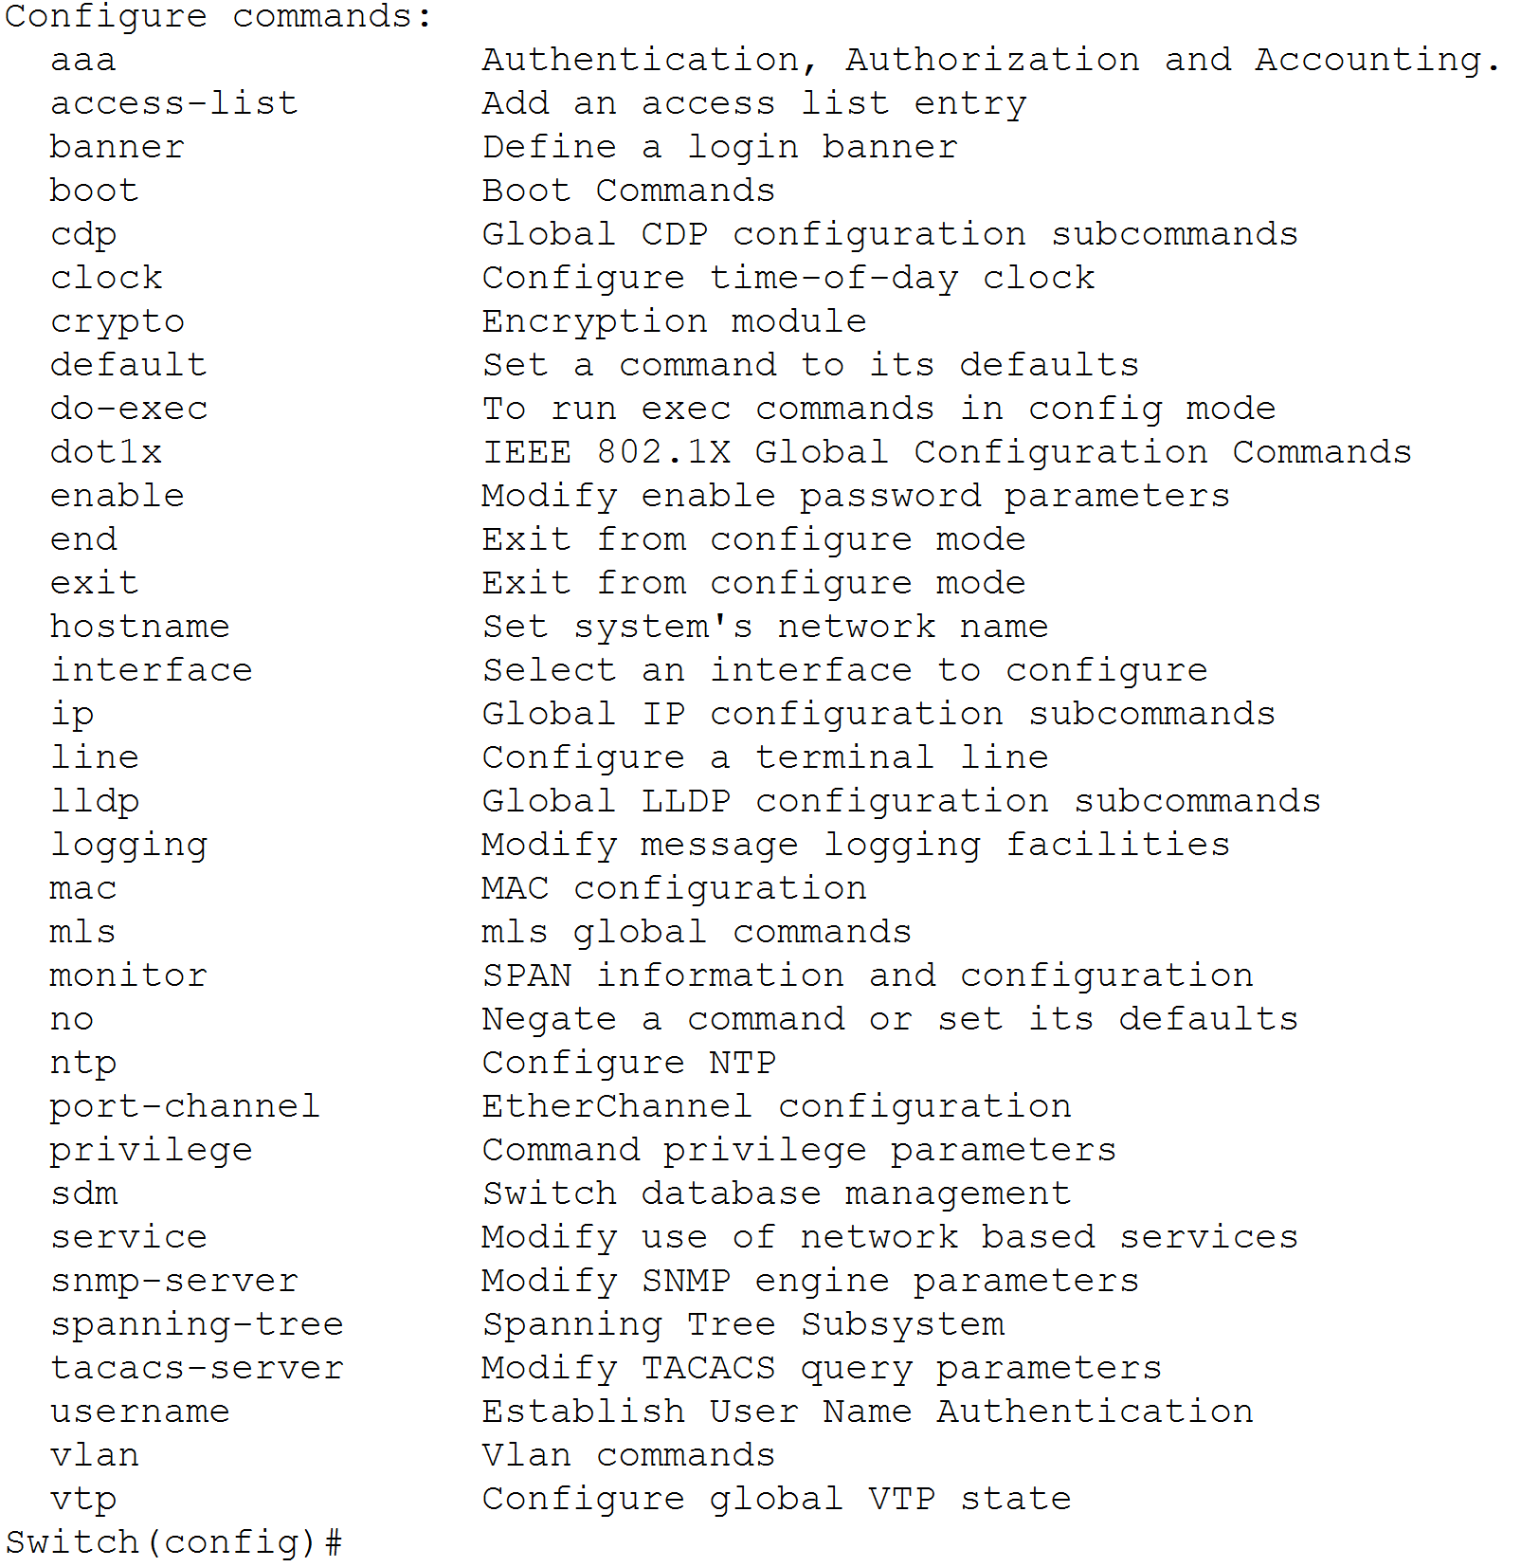

**SOFTWARE USED:-**

**OPERATING SYSTEM**

An operating system (OS) is the program that, after being initially loaded into the computer by a boot program, manages all of the other application programs in a computer. The application programs make use of the operating system by making requests for services through a defined application program interface (API).



**CISCO PACKET TRACER**

Packet Tracer is a cross-platform visual simulation tool designed by Cisco Systems that allows users to create network topologies and imitate modern computer networks. The software allows users to simulate the configuration of Cisco routers and switches using a simulated command line interface.

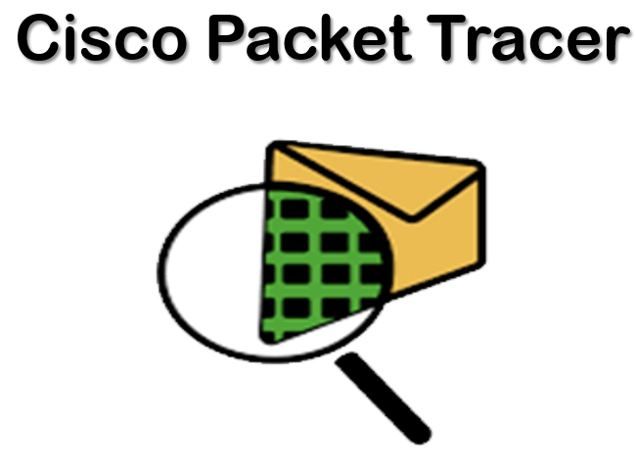

**CAMPUS LAYOUT**

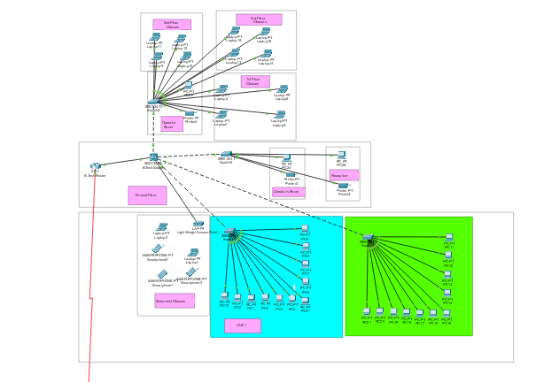

**NO. DEVICES (ARRANGEMENT IN RACKS)**

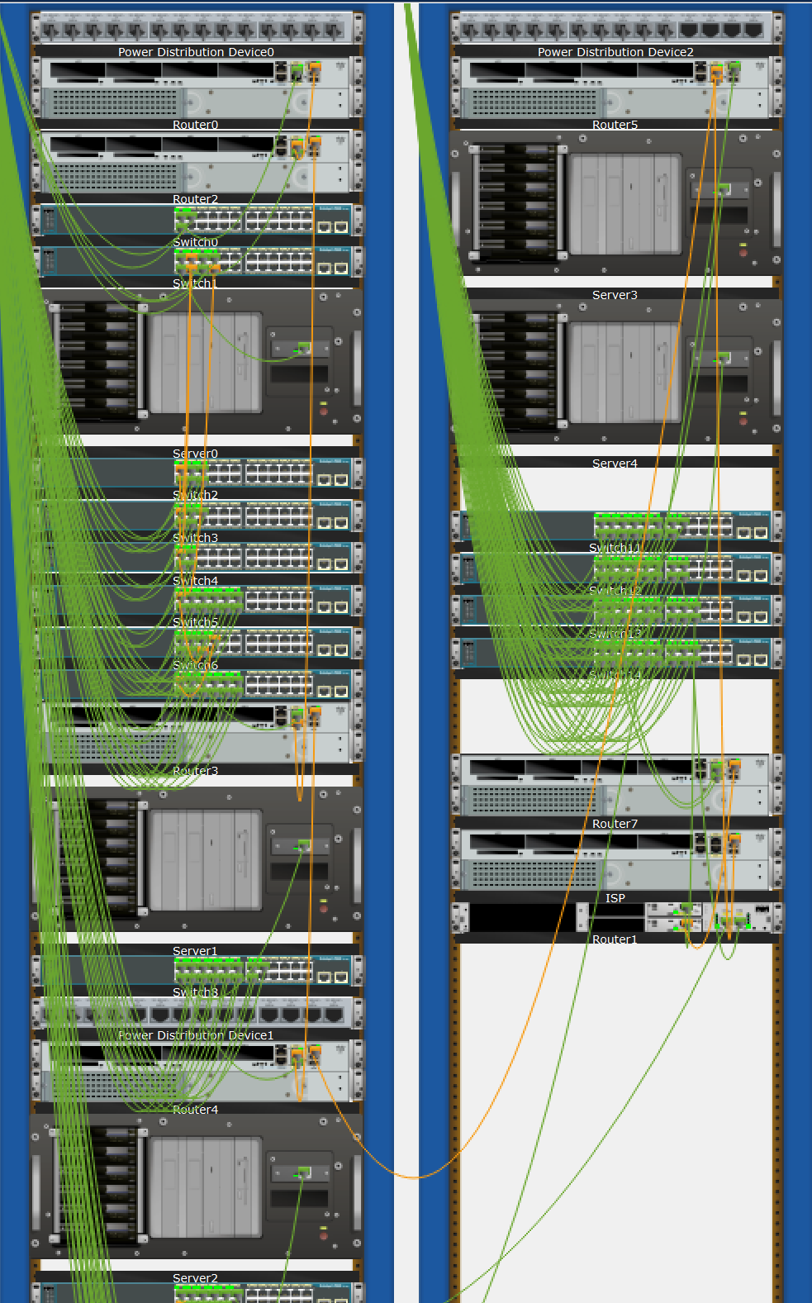

**MAIN ROUTERS**

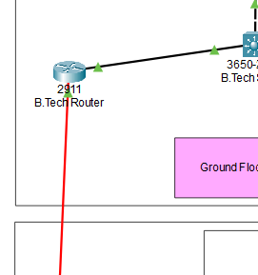

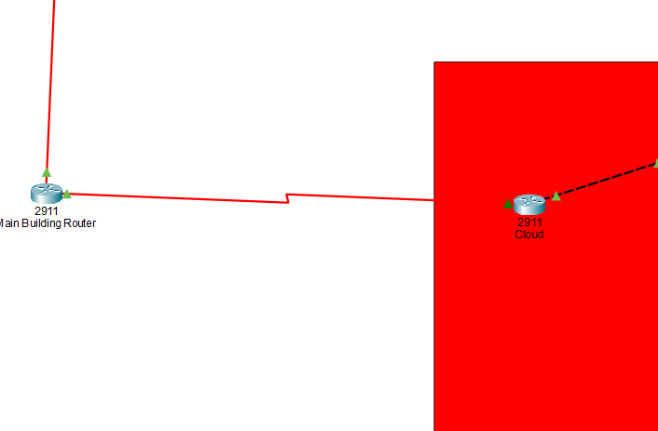

**FINAL LAYOUT AND CONNECTIONS**



**Implementation Network Devices**

Developing the existing Lan system:

* + The basis of the LAN core is Cisco Catalyst 6509 switches equipped with Cisco 720 supervisors and Virtual Switching System (VSS), as well as Cisco 4500 switches, combined in a stack with the data transmission ports at 10 Gb/s bandwidth capacity. Switches create a platform for additional services, such as content processing, firewall (the project uses the Cisco firewall), intrusion prevention system, application of IPsec security tools, the arrangement of protected VPN channels, network analysis and acceleration of Secure Sockets Layer (SSL) connections.

Mobility Services Engine (MSE) solution and 300 Cisco Aironet 1140 access points were used.

* + The Cisco Aironet 1140 Series is a component of the Cisco Unified Wireless Network, which can scale up to 18,000 [access points](https://www.cisco.com/en/US/products/ps5678/Products_Sub_Category_Home.html) with full Layer 3 mobility across central or remote locations on the enterprise campus, in branch offices, and at remote sites.
  + The Cisco Unified Wireless Network is the industry’s most flexible, resilient, and scalable architecture, delivering secure access to mobility services and applications and offering the lowest total cost of ownership and investment protection by integrating seamlessly with the existing wired network.

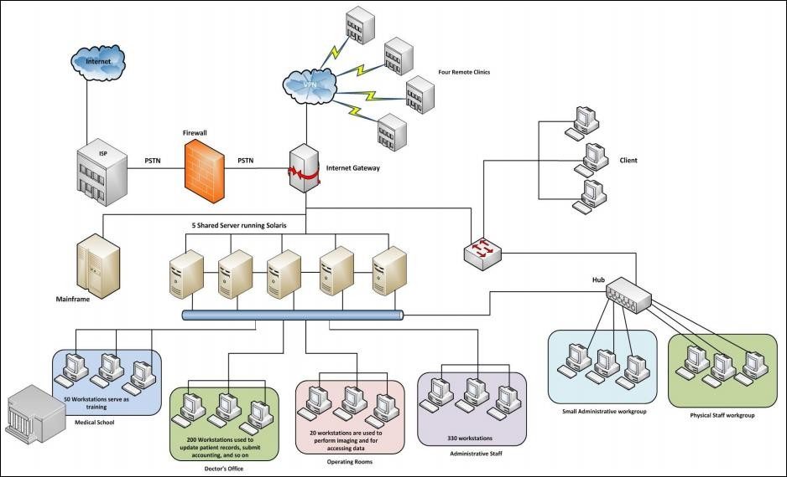

*Above is the pictorial representation of the proposed network*

Cisco Unified Computing System (UCS) solution allowed the integration of computer and network resources as well as storage and virtualization systems as part of an energy efficiency system. Cisco Unified Computing System platform notably simplifies traditional architecture and significantly reduces the number of devices to be purchased, to connect by wires, to supply with electricity and cooling, to protect and maintain. This solution is the foundation of complex optimization of the virtualized medium while maintaining the ability to support traditional operating systems and applications stacks in physical medium. This overall infrastructure developed allowed integration of several functionally different physical networks into one, such as guest network, hotel management network, telephone network and IP-Television network. The convergence within single network reduced hotel expenses for constructing and managing several dedicated networks which traditionally remain separate in hotels.

The term unified computing system is often associated with Cisco. Cisco UCS products have the ability to support traditional operating system ([OS](https://whatis.techtarget.com/definition/operating-system-OS)) and application stacks in physical environments, but are optimized for [virtualized](https://searchservervirtualization.techtarget.com/definition/virtualization) environments. Everything is managed through Cisco UCS Manager, a software application that allows administrators to provision the server, storage and network resources all at once from a [single pane of glass](https://searchconvergedinfrastructure.techtarget.com/definition/single-pane-of-glass). Similar offerings to Cisco UCS include HP BladeSystem Matrix, Liquid Computing's LiquidIQ, Sun Modular Datacenter and InteliCloud 360.

CONCLUSION

- The smart college network was built and implemented.

- Various End Devices, IOT device, routers and switches were deployed.

- The system implemented a wireless network inside the rooms using a home gateway.

- Various conditions were set inside the IOT monitor of the home gateway and devices were configured to connect to the home gateway.

- The prototype design was based in hostel which can later be implemented around classes.

Future Scope

With the advent of the Internet age, the impact of our education is unprecedented, and it also provides a rapid leap for education opportunities, education should be oriented towards modernization, facing the world, facing the future, we must first face the network. Educationcan only make a combination with network in order to keep up with progress and development of times. The premise of network education is the construction of the network, and as the construction of the campus network is not only the construction of the network hard environment, but also must include the campus network maintenance and security, campus network resources and the effective application of the campus network and other three Link.

Only the full and effective application of the campus network in order to make the entire teaching model and the educational concept of a complete change in order to apply the new century to cultivate high-quality creative and complex talents needs for the campus network

construction, not applicable to all schools program, even for a school, it is impossible to have the best program, only the better program.

References

[https://www.netacad.com](https://www.netacad.com/)

<https://www.youtube.com/c/NetworkkingsOrgtraining>

[https://www.emetechnologies.com](https://www.emetechnologies.com/)